**Course work. Part 3**

**Logical Design**

**Goal:** to translate the conceptual data model into a logical data model and then to validate this model to check that it is structurally correct. A logical data model includes the complete ER-diagram in the 3 NF and a supporting information.

**Plan:**

1. Complete ER-diagram to the 3NF (third normal form). Note: even if the ER-diagram already was normalized during Part 2, copy it here again to confirm it.

2. Describe all functional dependencies for all tables of the database.

3. Describe all your actions to achieve the 3NF comparing with the Part 2, description includes before and after states with detailed functional dependencies (see the example of a description in the Lecture 4). Here you should provide: 1) at least one example for UNF -> 1NF, 2) at least one example for 1NF -> 2NF, 3) at least one example for 2NF -> 3NF (if you didn't have such cases during you work, imagine and present such examples according to your database). Also include results from the many-to-many relationships.

4. Describe every entity of your database like in the following example. For the column with attribute’s types use: N – for numeric, C – for character, D – for date, B - for boolean. For Note (constraints) column specify if the attribute is a Primary Key, Foreign Key, NOT NULL (in other words, required field), UNIQUE or another constraint for a value.

Students entity (for example)

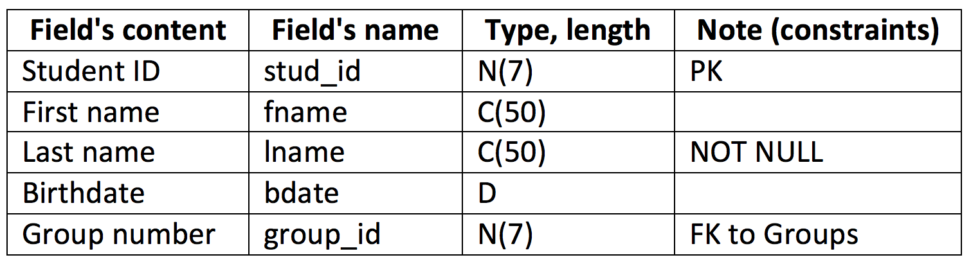

**Upload:** *.doc/ *.pdf

**Materials:**

Lectures 3, 4;

Connolly, Thomas M. Database Systems: A Practical Approach to Design, Implementation, and Management.